H.T No
Regulations:
A17

Sreenidhi Institute of Science and Technology
(An Autonomous Institution)
Code No: 6U202 Date: 24-June-2019 (FN)

M.Tech I-Year II-Semester External Examination, June - 2019 (Regular)
DESIGN OF FAULT TOLERANT SYSTEM (DSCE)

Time: 3 Hours Max.Marks:75

Note: a) No additional answer sheets will be provided.
b) All sub-parts of a question must be answered at one place only, otherwise it will not be valued.
c) Missing data can be assumed suitably.

Part - A Max.Marks:25

Answer all QUESTIONS.

1. | What is a maintainability? | [3M]
2. | What are the advantages of Berger Codes? | [3M]
3. | Explain fault ATPG? | [3M]
4. | What is unate function? | [3M]
5. | Explain about Multiple Scan Chains. | [3M]
6. | What is mean by 2-out-of-4 Constant –Weight-Code? | [2M]
7. | What is a Soft error and Hard error? | [2M]
8. | What are the properties of Reed Muller's expansion technique? | [2M]
9. | What are the advantages of the LSSD technique? | [2M]
10. | What are the key elements of BIST Architecture? | [2M]
Part – B Max.Marks:50
ANSWER ANY FIVE QUESTIONS. EACH QUESTION CARRIES 10 MARKS.

11. | a) | Calculate the reliability(R_{AB}) of the following system.  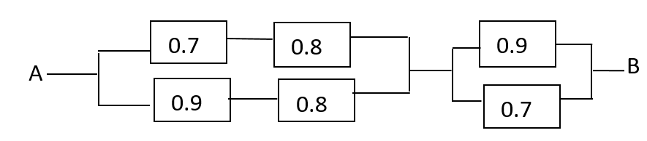 | [5M]
 | b) | Explain the three channel comparator and detector of Sift-Out-Modular Redundancy (SMR). | [5M]
12. | a) | Explain design of totally self checking check. | [5M]
 | b) | Construct a state assignment and excitation table for the following fail safe state machine using Berger code. | [5M]
  PS | NS, Output
  PS | X=0 | X=1
  A | E,0 | B,0
  B | C,0 | D,0
  C | A,0 | D,0
  D | E,0 | D,1
  E | A,0 | D,1
13. | a) | Discuss about ATPG (Automated Test Pattern Generator) for single stuck fault in combinational circuits. | [5M]
 | b) | Explain the D algorithm with an example. | [5M]
14. | a) | Derive the expression of Reed Muller's expansion. | [5M]
 | b) | Describe in detail Testability, Controllability and Observability. | [5M]
15. | a) | Explain the Scan design requirements. | [5M]
 | b) | Design a combinational Scan structure with FF’s such a way that the structure can be fully tested by compact ATPG patterns. | [5M]
16. | a) | What are the factors to be considered to choose a BIST Architecture? | [5M]
 | b) | Construct a minimal test set for pseudo exhaustive test if it is having parameters p=5 and w=3 with constant weight pair (1,4). | [5M]
17. | a) | Explain the principle of Five- Modular Redundancy (5 MR) with a neat diagram. | [5M]
 | b) | Explain the Generic offline BIST Architecture. | [5M]

-- 00 -- 00 –

